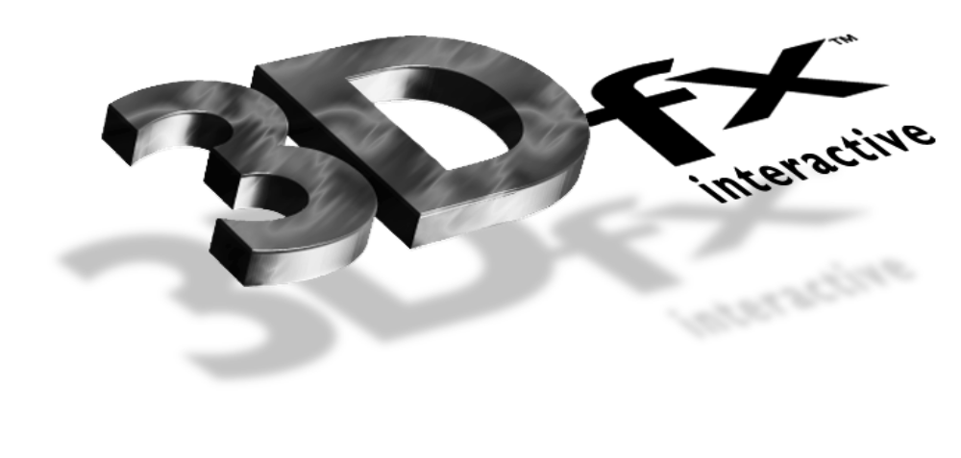

Release Notes

3Dfx Interactive Arcade Toolbox

ATB Version 0.3
13 September 1996
Copyright © 1995, 1996 3Dfx Interactive, Inc. All Rights Reserved

3Dfx Interactive, Inc.
415 Clyde Ave., Suite 105
Mountain View, CA 94043
Phone: (415) 934-2400
Fax: (415) 934-2424

Installation
Compilers
Compiling ATB Programs
Hardware Support
Obsidian™
Righteous 3D™
Operating Systems
DOS Notes
Windows95 Notes
Windows NT Notes
Demo Programs
Bugs
Bug Reporting
New with this release

Installation
Please see the document titled Installing and Using the Obsidian™ High Performance 3D Graphics Accelerator for installation instructions. Glide version 2.0b3 should have been installed previously.

Compilers
Supported Compilers Are:
- Microsoft® Visual C++ Version 2.2, 4.0, 4.1, 4.2 for Windows95 and Windows NT.
- Watcom C/C++ 10.6 for Windows 95, Windows NT, and DOS.

Compiling ATB Programs

Include And Library Files
The following header files are necessary to interface to each of the components of the Arcade Toolbox.
LIBRARY | HEADER | LIB
Utility | atutil.h | atu.lib
Math | atmath.h | atm.lib
Input | atinput.h | ati.lib
Rendering | atrender.h | atr.lib
Scene Management | atscene.h | ats.lib
Audio | ataudio.h | ata.lib

Path
On DOS, dos4gw.exe must be in your path. On Windows, sst1init.dll and glide.dll must be in your path.

Hardware Support
Glide and ATB support the following products:

Obsidian™
Glide 2.0b3 supports either one or two Texelfx chips (Amethyst™) . Further, it supports DACs from either ICS or AT&T.

Righteous 3D™
This release of Glide supports the Righteous3D board from Orchid.

Operating Systems
ATB supports Windows95, Windows NT and DOS. There is no native support in the development release for OS/2 or Linux.

DOS Notes
Glide, and therefore ATB, does not support the DOS/4GW Virtual Memory Manager(VMM) in stand-alone DOS shells.

Windows95 Notes
If you are running under Win95 and you have less than 24MB of RAM you must change your DOS properties settings. The value for DPMI memory must be changed from AUTO to 16384. The initial environment setting must also be changed from AUTO to a minimum of 4096 for some demos.

Windows NT Notes
Glide programs built for DOS4GW cannot be run under Windows NT.

Demo Programs
The following demos are present on the CD:
atsflip - a simple model viewer that allows you to load files in a number of different formats
fight - uses ATB to create a fighting demo that demonstrates many of the advanced features of the 3dfx hardware including: texture mapping, bilinear filtering, mip mapping, dynamic lighting, fog.
wiz - demonstrates the use of lighting maps to produce high quality textured environment’s. There are 5 rooms to explore
flipper - an underwater demo that demonstrates geometric animation, advanced texture mapping (including projected textures), audio and the use of one or two TMU’s.
race - a racing demo that demonstrates the advanced rendering features (bilinear filtering, mip mapping, fog) provided by 3dfx hardware and the database loading, frustum culling and rendering provided by ATB.
demoroom: This demo was designed to show off multi-pass projected textures. The projected textures themselves consisted on mono color images, true color images, and animated images. Also shown in this demo are very high frequency textures -- showing off the importance of mip mapping and bilinear filtering.
fltflip - a preliminary viewer for MultiGen’s Open Flight format. This is a very preliminary release of our loader and viewer. As the development effort progresses we will support more features of the Open Flight format and we will provide better integration with the remainder of ATB.
Note: neither fight or wiz require any environment variables to be set to determine the location of their data files. If you set FIGHT_LOAD_PATH (or WIZ_LOAD_PATH) ensure that the fight.bof (wiz.bof) file is located in the specified search path. If these variables are not set the program assumes the data files are in the same directory as the executable (which is where the setup program installs them).
The program atsflip does use an environment (AT_LOAD_PATH) to determine where the files to be viewed are located. This variable is setup by the batch files provided in the flip directory. To view other files simply set this variable to the directories containing the files.
The environment variable SST_DUALHEAD can be used in all the demos to disable setting of the pass through mode when using two separate monitors (one for displaying windows and one for displaying the demo graphics).

Bugs

Bug Reporting
At this time ATB is provided in source code form on as-is basis and is NOT a supported product. If you have any questions or suggestions for enhancements please forward them via electronic mail to devsuppor@3dfx.com. Your comments will be reviewed and considered. 3Dfx Interactive does not guarantee that your questions will be answered nor your suggestions be included in future releases.

New with this release

The following features are new/changed in this release:
- support for detailed, projected and animated textures
- support for multiple TMUs,
- new rendering primitives: line segments and Open Tri sets
- new ATS node types: sequence, billboard and LOD nodes
- preliminary Alias RGT and OpenFlight ATS loaders
A new ATB manual is included with this release. The sections on texture mapping have not been updated so please refer to the ATR sources for descriptions of these API’s and to the demo code for examples of useage.

